

Online Shopping Store

A Software Project Submitted

By

|  |  |
| --- | --- |
| **Name** | **ID** |
| Farhan Haseen Ibn Reaz | 17-33161-1 |
| Mehedi Hassan Misson | 17-33164-1 |
| Kazi Fazlay Rabbi | 17-33917-1 |
| Anik Sikder | 17-33613-1 |

Under the supervision of

Dr. Ashraf Uddin

Senior Assistant professor & Special Assistant

Office of Student Affairs

Department of Computer Science

Faculty of Science and Information Technology

American International University Bangladesh

Spring Semester 2019-2020

**Disclaimer**

This is to certify that this project is our original work. There exists no other part of this project elsewhere that has been submitted partially or fully for the award of any other degree. Any material reproduced in this project has been properly acknowledged.

________________________________________

1. Name: Farhan Haseen Ibn Reaz

ID: 17-33161-1

________________________________________

2. Name: Mehedi Hassan Misson

ID: 17-33164-1

________________________________________

3. Name: Kazi Fazlay Rabbi

ID: 17-33613-1

________________________________________

4. Name: Anik Sikder

ID: 17-33917-1

**Approval**

The Software Project or Project titled “Online Shopping Store” has been submitted to the following respected members of the Board of Examiners of the Faculty of Science and Information Technology in partial fulfillment of the requirements for the degree of Bachelor of Science in Software Engineering on xth x 2020 by the following students and has been accepted satisfactory.

|  |  |
| --- | --- |
| ____________________________  **Dr. Ashraf Uddin**    Faculty& Supervisor  Department of Computer Science  American International University- Bangladesh | ____________________________  **Dr. M M Mahbubul Syeed**  Head(Undergraduate)  Department of Computer Science  American International University- Bangladesh |
| ____________________________  **Professor Dr. Tafazzal Hossain**  Dean in Charge  Faculty of Science & Technology American International University-Bangladesh | **Dr. Carmen Z. Lamagna**  Vice Chancellor  American International University-Bangladesh |

**Acknowledgements**

We would like to take the chance to express our gratitude to our honorable teacher & Supervisor Dr. Ashraf Uddin, for his continuous guidance and support regarding this report. Besides this, we have found so many sincere and productive advices from many people that we would like pay homage to them. We convey our gratitude to our honorable Vice Chancellor, Dr. Carmen Z. Lamagna for encouragement.

Table of Contents

**Chapter 1: Statement of Work** 9

1.1 Initiation 9

1.2 Objectives 9

1.3 Proposed System 10

1.4 System Features 10

1.5 Environment 12

1.5.1 Organizations Involved 12

1.5.2 Processing 12

1.5.3 Security 12

1.6 Assumptions 13

1.7 Constraints 13

1.8 System Requirements 14

1.8.1 Key Aspects of Proposed System 14

1.8.2 Hardware 14

1.8.3 Software 15

1.9 Project Time & Cost 15

1.9.1 Estimated Time 15

1.9.2 Domain and Hosting Cost 16

1.10 Assessing possible risk issues 18

Chapter 2: Software Requirement Specification 20

2.1 Scope 20

2.2 Present-Day Software Overview in Market 20

2.3 Overview of the Proposed System 21

2.4 Benefits of Proposed System 21

2.5 System Features 21

2.6 Hardware and Software Requirements 23

2.6.1 Hardware 23

2.6.2 Software 23

2.7 Human Resource Requirements 23

2.8 Resource Allocation 24

2.9 Constraints and Limitations 24

2.10 Budget 26

Chapter-3: Diagram 27

3.1 Use Case Diagram 27

3.1.1 Admin Functionality 27

3.1.2 Supplier Functionality 28

3.1.3 Unregistered User 28

3.1.4 Registered User 30

3.2 Activity Diagram 32

3.3 Prototype Images of Proposed System 33

Chapter-4: Software Project Management Plan 37

4.1 Document History and Distribution 37

4.2 Overview 37

4.2.1 Purpose 37

4.2.2 Project Scope 37

4.2.3 General Constraints 37

4.3.2 Schedule Summary 38

4.4 Resources of the Software Project Management Plan 38

4.6.4 Resource Acquisition Plan 40

4.6.5 Project Staff Training Plan 40

4.7 Budget Allocation Summary 40

4.8 Control Plan 41

4.8.1 Requirements Control Plan 41

4.8.2 Schedule Control Plan 41

4.9 Risk Management 42

4.10 Element of Risk Management 42

4.12 Process Model 43

4.13 Methods, Tools and Techniques 43

4.15 Product Acceptance Plan 44

4.16 Monitoring and Control plan 44

4.17 Verification and Validation 44

4.18 Requirement Tracing Plan 44

4.19 Documentation Plan 44

4.20 Quality Assurance Plan 44

4.21 Problem Resolution Plan 45

4.22 Process Improvement Plan 45

4.23 Conclusion 45

REFERENCES 45

# **Chapter 1: Statement of Work**

## Initiation

The beginning of the project will be about investigating the potential benefits when undertaking such a project. The main goal is to cover all matters related with the project such as, features, capability, performance, security, throughput etc. Alongside that, the amount of time and other resources will need to be estimated in order to achieve the result as desired.

An analysis must be done that takes the project relevant factors into account, including economic, technical, legal, and scheduling considerations. This is done to ascertain the likelihood of completing the project successfully. This line of work is specifically called as feasibility study.

Project managers use this study to find out the complications of undertaking a project before time and money are invested upon it. Undergoing through the activities of feasibility study, many factors need to be considered. The total allocation and management of time and work required to be calculated in order for the project to come to a state of completion is one of the primary concerns. For instance, components such as cash reserves, labor output, production rate, expense of raw materials etc. will need to be attended to, in the vast area of work in our regular schedule. Once all the issues and matters associated with feasibility study have been addressed, a good grip about the total time and the expense can be developed in accomplishing the project goals and getting the desired outcome.

Only when the study is complete, the next phase can commence, which is making the main plan for the project. Feasibility study provides the team with necessary details about the project can be achieved or not. This study has assisted many companies around the world in determining which projects are possible to develop and which ones to shut down. It is entirely possible that a project invested with proper resources, ultimately came out fruitless and generated no revenue whatsoever.

The study being given the right time an effort to be completed, the next phase can begin. The main development plan made for a project, will give important guidance to the whole development team. The requirements are required to be set and managed in a coordinated manner in order for tasks to be initiated and finished in due time. The activities mapped out in the plan, will be followed throughout the entire development cycle and as such it is of paramount importance, time and thought are both put into making the plan. Often, in the middle of doing the project activities, new and better suggestions can be made and the plan can be updated accordingly. Once the plan is developed, the execution of the activities to accomplish the project can begin.

## 1.2 Objectives

The objectives of the project are made according to requirements of the client. Negotiation and adjustment are also made with client to building features that successfully construct the online infrastructure of a shopping system. The shopping website is built upon the fact that it can provide people with better buying experience. It makes use of various technologies to get the latest deals and offers that are presentable to the audience more quickly, easily, colorfully and attractively. It can do this for a much wider audience of the world and with the promise that everyone gets their products delivered faster than the real world. Anyone can visit the online shop and view information about the site from anytime and anywhere provided that the person has stable internet connection. The gist of the project is to develop a web application which gives a much more enriched and comfortable shopping experience than its real world counterpart.

## 1.3 Proposed System

The system that this project intends to make is basically an **Online Shopping Store**. This web application or software is made with the sole purpose of giving the customer sleek transition to our service from basically anywhere and anytime. This system can make a customer’s shopping spree much easier, quicker and accessible.

Expected Benefits of the Proposed System are given:

* No real world hassle for waiting in queues and crowds
* Client will be able to make better decisions on what to buy and system will find the best offers and deals
* Options to buy products individually or in a multiple set via shopping cart
* Better searching options based on clients preferences and budgets
* Keeping product line up to date with time
* Give reviews and ratings to the desirable products
* Choices from the best products available in the current respective time
* Fast and easy purchasing
* Viewable transaction history provided with details

Another important aspect is that it’s quite impossible currently to track how a single customer comes to a physical store thinking where to browse before making a buying decision often. However, a customer’s every click can be tracked in an online store, providing valuable insights of the buyer’s purchasing decisions and creating the way for more marketing opportunities to entice certain customers who may be on the verge of purchasing a certain product. As a result, an ecommerce system such as this online shopping store provides real time data and analytics about the products and the customers, which is good for both the customers and developers.

## 1.4 System Features

The user types of this software system are given below:

**Admin**

* Modify existing customer information if needed
* Modify, add and delete any system user
* Modify, add and delete any role of employee
* Modify, add and delete product details
* Modify, add and delete of product offers and deals

Customer can be of two types:-

**Unregistered User**

* Browse around the website
* View at various products and its details
* Check availability of products
* Use searching filters to find products
* Look at what the website is about

**Registered User**

* View the contents of the website
* Look around various products and its details
* Check availability of products
* Apply price comparisons between goods
* Use searching filters to find products
* Look at what the website is about
* Buying products individually
* Buying multiple products using a shopping cart system
* Payment options will be available
* Keep profile of the customer up to date
* View purchasing history
* Give reviews and ratings to products
* Add any product to favorite list

**Supplier**

* Check supply of products
* View the product shipping records
* Check availability of products
* View the product details
* Modify, add and delete product details if required

The following are the modules of the system. They are given below:

**Profile Module**

* A user can view his/her personal details.
* Details can be edited.
* New password can be made.
* Profile pictures can be uploaded; old or new.

**Product Module**

* Various products can be viewed.
* Once a product is selected, its details and photo are loaded.
* A customer can give a review or rating to the product.
* A customer can add the product to favorite list.

**Shopping Cart Module**

* Multiple products can be bought using the cart system.
* Customer can cancel the cart order.
* The customer can add and delete products from the cart.

**Payment**

* Customer can buy products individually.
* Customer can buy products in a cart.
* Payment options will be available.
* Customer can cancel the order.

## 1.5 Environment

## 1.5.1 Organizations Involved

Project Client: -----------

Developers: Online Shopping Store Development Team

Stakeholders: The project client and any online user

## 1.5.2 Processing

* This will be a web application which a graphical user interface is present enabling any user to browse with comfort in any browser
* This will be independent of any browser. A website or web application which can be interacted on any browser.
* Administrator, Employee and Customer makes up the three integral parts of the system.
* Secured data transferring for all users is promised.
* There will be a database server storing the information of all the registered users.
* The information of a certain user can be viewed by the user himself/herself and the administrator of this software system.
* A validated and protected login system is ensured.
* The details of loggings by customers and employees will be recorded.

## 1.5.3 Security

* For any user trying to log in, authentication will be mandatory to access the application.
* A user must be registered to log in to the system.
* Every purchase whether single or cart, will be gone through our authentication processes.
* The authentication and validation procedures are fully secured.
* A customer can login and logout.
* The password changing process is fully secured.
* A customer can update his/her profile details.
* A customer can register a new account without any hassle.

## 1.6 Assumptions

**Business strategy:** This aspect is one of the most important topics. The assumption is that if a project is undertaken with specific business goals in mind, and those goals are getting out of top focus, it can be a quite disastrous for the entire team.

**Time:** Time is very crucial for a project. Deadlines can make or break the entire development cycle. It can be influenced by resource availability or scarcity, technology, quality factors, financial limitations, and other assumptions. There should be a contingency plan and method to address these time based assumptions.

**Quality:** In any case, quality plays a big role in being a critical determinant of success when companies are required to adhere to specifications in order to meet client expectations. There are also safety guidelines to follow. In such situations there is usually no wiggle room for error. Safety is concerning as government demands it. Quality specifications have to be adjusted accordingly.

**Budget:** The financial component of the project has to be addressed. Even if there is a good amount of funding money, sponsors and stakeholders will still be concerned about cost of any project. Depending on the industry and project goals and objectives, financial assumptions can become secondary. Especially when talking about target audience, such as niche or plentiful, a project can be affected. A highly well-regarded, safety governed, or legally legislated project can be made.

**Environment:** The workplace where the development work will take place might also bring up some assumptions. The work should be conducted under conditions which favors the environment. If a project is initiated and an assumption is that work will be conducted at a particular location and the location turns out to be quite problematic, it can negatively impact the entire project and actions should be taken immediately.

## 

## 1.7 Constraints

* Bandwidth: Due to network issues, there may be problems such as, losing server connection. Depending on the hardware of the end-user, he/she might also face some latency issues. There also might be other technical errors.
* Database: The database server we will use to store all user data is MySql. If the user queries exceed more than server’s limitations by chance, we need to check databases and manage the table data in a conservative way.
* Web Server: There can sometimes be too much requests to handle for the server. In this case, there will be a slow experience for the users. At other times, an attack such as the DDoS attack capitalizes on this very issue to halt the server.
* Scope: The development team might not be able to fully realize the system in time. Overestimation, mismanagement etc. have influence over scope.
* Budget: The budget prepared for the project may be overused and there may be more development work to do.
* Excessive System Usage: Parallel use of other web-based applications with this software may hamper the connection and may take more time for a query to process with slow bandwidth or eventually lose the connection.
* Time: Time is always a constraint. Deadline can be given at an early stage and the team might not able to deliver.
* Security Issues: If user doesn’t want to buy SSL security then client applications will not using any public key encryption service like SSL certificate (i.e. 128 bit RSA encryption). As a result, there may be risks Such as the ones down below:
* **Authentication problem:** Due to unpredictable problems in computers, the server may not recognize/confirm an actual valid user sometimes.
* **Denial of service:** This is an attack by hackers to prevent the service from being used by online users. Attacks such as DDoS may render a network unavailable as the resources of the network gets exhausted.

## 1.8 System Requirements

## 1.8.1 Key Aspects of Proposed System

* Reduce overall staff cost
* Efficient and smooth browsing experience
* Quick and easy purchase/transaction
* Monitor the performance of system
* Reduce faults and errors in the system
* Manage traffic in server
* Non-dependency based databases
* No vulnerability in security
* Reduce loading times
* Gain client’s full satisfaction

## 1.8.2 Hardware

➢ Minimum requirements for server:

* Processor: Xeon based microprocessor.
* RAM: 18 GB.
* System Type: Windows (64-bit).
* Storage: 280 GB SSD.

➢ Minimum requirements for client:

* Processor: 2.4 GHz; For example, Intel Core 2 duo.
* RAM: 1 GB.
* System: Windows, MAC OS X, Linux.
* Web Browser: Firefox, Google Chrome.

## 1.8.3 Software

* Code Writing: Visual Studio Code / Sublime Text
* Programming Language: PHP
* Database: MySQL
* Request Handling Server: Apache Web Server

## 1.9 Project Time & Cost

## 1.9.1 Estimated Time

The proposed project is basically an **Online Shopping Store**. This software or web application is promised to give the customer immediate access to our service from basically anywhere and anytime with excellent experience. In order to create such a system, we need to know the wants and demands of people and what features are useful to them. Much time is spent on researching and checking the feasibility of the project. Then if feasibility is passed, then planning is made for the whole development cycle. The most time-consuming parts of the entire development cycle will be the coding and testing phases. So taking all of these into account, the time estimated to complete this project is approximately 10 months.

Here is the scheduling for the project:

|  |  |  |  |
| --- | --- | --- | --- |
| **Serial No.** | **Task** | **Week Number** | **Total Weeks** |
| 1.0 | Feasibility Study | 1st-2nd | 2 |
| 2.1 | Collect Requirement Information | 2nd-3rd | 1 |
| 2.2 | Identify User Requirements | 3rd | 1 |
| 2.3 | Set Requirements | 3rd | 1 |
| 3.0 | Planning | 4th | 1 |
| 4.0 | Designing | 5th-8th | 4 |
| 5.0 | Coding | 8th-11th | 4 |
| 6.1 | Developing Test Plan | 11th | 1 |
| 6.2 | Executing all the Test Phases | 12th | 1 |
| 6.3 | Debugging | 13th-14th | 2 |
| 7.0 | Release | 15th | 1 |
| 8.0 | Documentation | 15th-18nd | 4 |

## 1.9.2 Domain and Hosting Cost

**Domain Cost:**

|  |  |
| --- | --- |
| **Domain** | **Registration** |
| .com | TK. 950 / year |
| .net | TK. 950 / year |
| .us | TK. 850 / year |
| .asia | TK. 1575 / year |
| .bd | TK. 2550 / year |
| .mobi | TK. 1950 / year |
| .tel | TK. 1650 / year |

**Hosting Cost:**

All plans below are shown according to the site webhostbd.com. Some of the plans are in the following:

**Plan A:** Tk. 1000/Year

* 1 GB SSD Storage
* 50 GB Data Transfer Monthly
* LiteSpeed Web Server
* 1 Addon Domain
* cPanel Control Panel
* FREE SSL Life Time
* FREE Weekly Backup
* Unlimited Sub Domains
* Unlimited Email Accounts
* Unlimited Databases

**Plan B:** Tk. 1500/Year

* 2 GB SSD Storage
* 100 GB Data Transfer Monthly
* LiteSpeed Web Server
* 2 Addon Domain
* cPanel Control Panel
* FREE SSL Life Time
* FREE Weekly Backup
* Unlimited Sub Domains
* Unlimited Email Accounts
* Unlimited Databases

**Plan C:** Tk. 2000/Year

* 3 GB SSD Storage
* 150 GB Data Transfer Monthly
* LiteSpeed Web Server
* 3 Addon Domain
* cPanel Control Panel
* FREE SSL Life Time
* FREE Weekly Backup
* Unlimited Sub Domains
* Unlimited Email Accounts
* Unlimited Databases

Thus, this concludes some examples of the plans. We have chosen plan C as we think this is suitable according to our estimated budget and time.

**The table below is the estimated domain and hosting service cost:**

|  |  |
| --- | --- |
| **Description** | **Cost** |
| Domain name(for 1 year) | 950 BDT |
| Hosting service (for 1 year) | 2,000 BDT |
| **Total** | **2,950 BDT** |

**1.9.3 Estimated Budget**

|  |  |  |  |  |  |  |
| --- | --- | --- | --- | --- | --- | --- |
| **Serial No.** | **Employees/Tools** | **Category** | **Number** | **Cost per month** | **Month** | **Total Cost (BDT)** |
| 01 | Project Manager | Staff Cost | 1 | 30,000 | 5 | 150,000 |
| 02 | Analyst | Staff Cost | 1 | 25,000 | 4 | 100,000 |
| 03 | Designers | Staff Cost | 2 | 10,000 | 1 | 20,000 |
| 04 | Developers | Staff Cost | 4 | 20,000 | 1 | 80,000 |
| 05 | Hardware Equipment | Overheads | As required | Not required | Not required | 170,000 |
| 06 | Tools | Overheads | As required | Not required | Not required | 30,000 |
| 07 | Testers | Staff Cost | 2 | 15,000 | 0.5 | 15,000 |
| 08 | Rent | Overheads | As required | 12,000 | 5 | 60,000 |
| 09 | Utilities | Usage Charges | As required | 4,000 | 5 | 20,000 |

The total estimated cost is 645,000 BDT.

## 1.10 Assessing possible risk issues

**1. Are the requirements understood by the software development team and the associated clients?**

**Answer:** Yes. The software developmentteam or the developers are selected carefully based on their knowledge and experience on making software projects. Also the requirements details are well organized that it is understood both by the developers and the associated clients.

**2. Is the group of end-users committed to their roles involved in the software project?**

**Answer:** Yes. The end-users are fully committed to possibly find all kinds of bugs of the system and also report back on features related to user experience.

**3. Has the software development team formally committed to support the project?**

**Answer:** Yes. The whole team is fully formallycommitted to support the project. They are dedicated to work on the project and deliver it feature complete and in time.

**4. Is the scope of the project stable?**

**Answer:** Yes. Project scope is stable. The software developmentteam is well suited for this job as they will promise to make the project within its scope. If any issues arise, then it will be adjusted accordingly.

**5. Is the software development team the right fit for this job?**

**Answer:** Yes. The software developmentteam has the right set of skills. The team members can do their work cooperating with each other as a team. They also have the knowledge to accomplish making this software.

**6. Does the team have prior usage/experience with the technology being used in this project?**

**Answer:** Yes. The team has prior usage/experience with the technology. They have the right knowledge about the technologies involved and via these technologies they will be able to implement the software.

**7. Are the project team and client notified about the possible risks?**

**Answer:** Yes. The software engineer team has estimated possible risks and their assessment and contingencies are also made. Clients are also being informed as well.

**8. Is the project team notified about the constraints of the project?**

**Answer:** Yes. The team is well informed about the constraints of the project. These issues have been researched by the team and with the right documentation. Adequate preparations have been made as well to deal with such constraints.

# 

# Chapter 2: Software Requirement Specification

## 2.1 Scope

The scope of the project is built around the fact that customers can have their shopping process be done with ease and comfort staying at their homes. Users will be able to see detailed day-by-day products of attractions and pick and choose which item to buy singly or in multiple via cart. The traditional way of shopping is actually going to the market, stores etc. and buying products off of different vendors. Due to the vast potential of the internet, a significant part of our lives is becoming digitalized. This includes online shopping centers. For some people, it is of no wonder that the online version of a shopping store is one of the many things. Since its inception, it has become very convenient to shop for products. Not only a lot of time is being spared but also one can escape from all the hassles and problems caused by mass people shopping.

The online shopping store is supposed to have the following features:

* Easy To Use

Our system help shopper what they want to get.

* Variety of Payment Options

Our system will provide different option for payment method.

* User Review

Give reviews and ratings to the desirable products

* Data scraping or web scraping

Lots of options to compare and contrast for purchasing

* Customer support

Customer support is one of the important e-commerce features. So this system will help customer if he does not know about the functionality properly.

* Opportunities of getting to see various products very easily
* Better searching options based on clients preferences and budgets
* Can buy products individually or in a multiple set via shopping cart
* Customers will be able to buy and find the best offers and deals
* Viewable transaction history provided with details

## 2.2 Present-Day Software Overview in Market

At present there are many online shopping stores in Bangladesh like Bdshop, Bagdoom, PriyoShop etc. These types of software are based only finding the product like mobile accessories, mobiles, watches etc. But sometimes there is a problem to identify the product because of less image quality. Another main issue is transportation. Many times, customer gets the product after the deadline (delay to delivery). In addition, transportation quality is poor.

## 2.3 Overview of the Proposed System

The project is developed with the sole purpose of giving the customer sleek transition to our service from basically anywhere and anytime. It is made both according to business goals and the user requirements. Negotiation and adjustment are also made with client to building features that successfully construct the online infrastructure of a shopping system. It makes use of various technologies to get the latest deals and offers that are presentable to the audience more quickly, easily, colorfully and attractively. It can do this for a much wider audience of the world and with the promise that everyone gets their products delivered faster than the real world. The gist of the project is to develop a web application which gives a much more enriched and comfortable shopping experience than its real world counterpart.

## 2.4 Benefits of Proposed System

Expected Benefits of the Proposed System are given:

* No real world hassle for waiting in queues and crowds
* Client will be able to make better decisions on what to buy and system will find the best offers and deals
* Options to buy products individually or in a multiple set via shopping cart
* Better searching options based on clients preferences and budgets
* Keeping product line up to date with time
* Give reviews and ratings to the desirable products
* Choices from the best products available in the current respective time
* Fast and easy purchasing
* Viewable transaction history provided with details

Another important aspect is that it’s quite impossible currently to track how a single customer comes to a physical store thinking where to browse before making a buying decision often. However, a customer’s every click can be tracked in an online store, providing valuable insights of the buyer’s purchasing decisions and creating the way for more marketing opportunities to entice certain customers who may be on the verge of purchasing a certain product. As a result, an ecommerce system such as this online shopping store provides real time data and analytics about the products and the customers, which is good for both the customers and developers.

## 2.5 System Features

The user types of this software system are given below:

**Admin**

* Modify existing customer information if needed
* Modify, add and delete any system user
* Modify, add and delete any role of employee
* Modify, add and delete product details
* Modify, add and delete of product offers and deals

Customer can be of two types:-

**Unregistered User**

* Browse around the website
* View at various products and its details
* Check availability of products
* Use searching filters to find products
* Look at what the website is about

**Registered User**

* View the contents of the website
* Look around various products and its details
* Check availability of products
* Apply price comparisons between goods
* Use searching filters to find products
* Look at what the website is about
* Buying products individually
* Buying multiple products using a shopping cart system
* Payment options will be available
* Keep profile of the customer up to date
* View purchasing history
* Give reviews and ratings to products
* Add any product to favorite list

**Supplier**

* Check supply of products
* View the product shipping records
* Check availability of products
* View the product details
* Modify, add and delete product details if required

The following are the modules of the system. They are given below:

**Profile Module**

* A user can view his/her personal details.
* Details can be edited.
* New password can be made.
* Profile pictures can be uploaded; old or new.

**Product Module**

* Various products can be viewed.
* Once a product is selected, its details and photo are loaded.
* A customer can give a review or rating to the product.
* A customer can add the product to favorite list.

**Shopping Cart Module**

* Multiple products can be bought using the cart system.
* Customer can cancel the cart order.
* The customer can add and delete products from the cart.

**Payment**

* Customer can buy products individually.
* Customer can buy products in a cart.
* Payment options will be available.
* Customer can cancel the order.

## 2.6 Hardware and Software Requirements

## 2.6.1 Hardware

➢ Minimum requirements for server:

* Processor: Xeon based microprocessor.
* RAM: 18 GB.
* System Type: Windows (64-bit).
* Storage: 280 GB SSD.

➢ Minimum requirements for client:

* Processor: 2.4 GHz; For example, Intel Core 2 duo.
* RAM: 1 GB.
* System: Windows, MAC OS X, Linux.
* Web Browser: Firefox, Google Chrome.

## 2.6.2 Software

* Code Writing: Visual Studio Code / Sublime Text
* Programming Language: PHP
* Database: MySQL
* Request Handling Server: Apache Web Server

## 2.7 Human Resource Requirements

The human resource requirements needed for implementing and operating the system are mentioned below:

* **Managing Payroll**: Payroll is a process where the employee gets paid for their work. In software management a payroll process should have to be established. An employee will be assigned to maintain an efficient payroll process to ensure that employee will be paid accurately.
* **Computer operator/Data entry operator**: A PC administrator is expected to transfer the online inquiry to the system so that a particular client will know how the system works. In that way we can directly communicate with our client. This will also help us to know what our client is actually wanted.
* **Storing Employee Data**: Keeping employee records accurate and up to date is essential for any software organization. If the organization does not store employee information then they will have difficult time to discover all the essential data. An employee will be assigned to keep track all the data who are currently working. It provides organizations a central and comprehensive view of the entire organization.
* **Hardware Specialist**: The job of a hardware specialist is to maintain all the computers. So if there is an occurrence of any equipment he/she may come and take care of those issues.
* **Recruitment**: Recruitment system is a process of selecting potential candidates for vacant position and hiring the candidates who fulfill the requirement of the organization. It includes several responsibilities, mainly selecting the best potential candidates who could help to achieve organization goal. An employee is needed to complete this recruitment process.

## 2.8 Resource Allocation

|  |  |  |  |
| --- | --- | --- | --- |
| **SL** | **Name** | **Category** | **Quantity** |
| 01 | Project manager | Human Resource | 1 |
| 02 | Analyst | Human Resource | 1 |
| 03 | Designer | Human Resource | 2 |
| 05 | Developer | Human Resource | 4 |
| 07 | Tester | Human Resource | 2 |
| 08 | Laptop | Equipment | 10 |
| 09 | Software | Equipment | As required |
| 10 | Internet Connection | Services | As required |

## 

## 2.9 Constraints and Limitations

**Assumptions and Dependencies**

**Business strategy:** This aspect is one of the most important topics. The assumption is that if a project is undertaken with specific business goals in mind, and those goals are getting out of top focus, it can be a quite disastrous for the entire team.

**Time:** Time is very crucial for a project. Deadlines can make or break the entire development cycle. It can be influenced by resource availability or scarcity, technology, quality factors, financial limitations, and other assumptions. There should be a contingency plan and method to address these time based assumptions.

**Quality:** In any case, quality plays a big role in being a critical determinant of success when companies are required to adhere to specifications in order to meet client expectations. There are also safety guidelines to follow. In such situations there is usually no wiggle room for error. Safety is concerning as government demands it. Quality specifications have to be adjusted accordingly.

**Budget:** The financial component of the project has to be addressed. Even if there is a good amount of funding money, sponsors and stakeholders will still be concerned about cost of any project. Depending on the industry and project goals and objectives, financial assumptions can become secondary. Especially when talking about target audience, such as niche or plentiful, a project can be affected. A highly well-regarded, safety governed, or legally legislated project can be made.

**Environment:** The workplace where the development work will take place might also bring up some assumptions. The work should be conducted under conditions which favors the environment. If a project is initiated and an assumption is that work will be conducted at a particular location and the location turns out to be quite problematic, it can negatively impact the entire project and actions should be taken immediately.

**Constraints**

* Bandwidth: Due to network issues, there may be problems such as, losing server connection. Depending on the hardware of the end-user, he/she might also face some latency issues. There also might be other technical errors.
* Database: The database server we will use to store all user data is MySql. If the user queries exceed more than server’s limitations by chance, we need to check databases and manage the table data in a conservative way.
* Web Server: There can sometimes be too much requests to handle for the server. In this case, there will be a slow experience for the users. At other times, an attack such as the DDoS attack capitalizes on this very issue to halt the server.
* Scope: The development team might not be able to fully realize the system in time. Overestimation, mismanagement etc. have influence over scope.
* Budget: The budget prepared for the project may be overused and there may be more development work to do.
* Excessive System Usage: Parallel use of other web-based applications with this software may hamper the connection and may take more time for a query to process with slow bandwidth or eventually lose the connection.
* Time: Time is always a constraint. Deadline can be given at an early stage and the team might not able to deliver.
* Security Issues: If user doesn’t want to buy SSL security then client applications will not using any public key encryption service like SSL certificate (i.e. 128 bit RSA encryption). As a result, there may be risks Such as the ones down below:
* **Authentication problem:** Due to unpredictable problems in computers, the server may not recognize/confirm an actual valid user sometimes.

**Denial of service:** This is an attack by hackers to prevent the service from being used by online users. Attacks such as DDoS may render a network unavailable as the resources of the network gets exhausted.

## 2.10 Budget

**The table below is the estimated domain and hosting service cost:**

|  |  |
| --- | --- |
| **Description** | **Cost** |
| Domain name(for 1 year) | 950 BDT |
| Hosting service (for 1 year) | 2,000 BDT |
| **Total** | **2,950 BDT** |

**The table below is the estimated cost of employees and other factors:**

|  |  |  |  |  |  |  |
| --- | --- | --- | --- | --- | --- | --- |
| **Serial No.** | **Employees/Tools** | **Category** | **Number** | **Cost per month** | **Month** | **Total Cost (BDT)** |
| 01 | Project Manager | Staff Cost | 1 | 30,000 | 5 | 150,000 |
| 02 | Analyst | Staff Cost | 1 | 25,000 | 4 | 100,000 |
| 03 | Designers | Staff Cost | 2 | 10,000 | 1 | 20,000 |
| 04 | Developers | Staff Cost | 4 | 20,000 | 1 | 80,000 |
| 05 | Hardware Equipment | Overheads | As required | Not required | Not required | 170,000 |
| 06 | Tools | Overheads | As required | Not required | Not required | 30,000 |
| 07 | Testers | Staff Cost | 2 | 15,000 | 0.5 | 15,000 |
| 08 | Rent | Overheads | As required | 12,000 | 5 | 60,000 |
| 09 | Utilities | Usage Charges | As required | 4,000 | 5 | 20,000 |

The total estimated cost is 645,000 BDT.

# Chapter-3: Diagram

## 3.1 Use Case Diagram

## 3.1.1 Admin Functionality

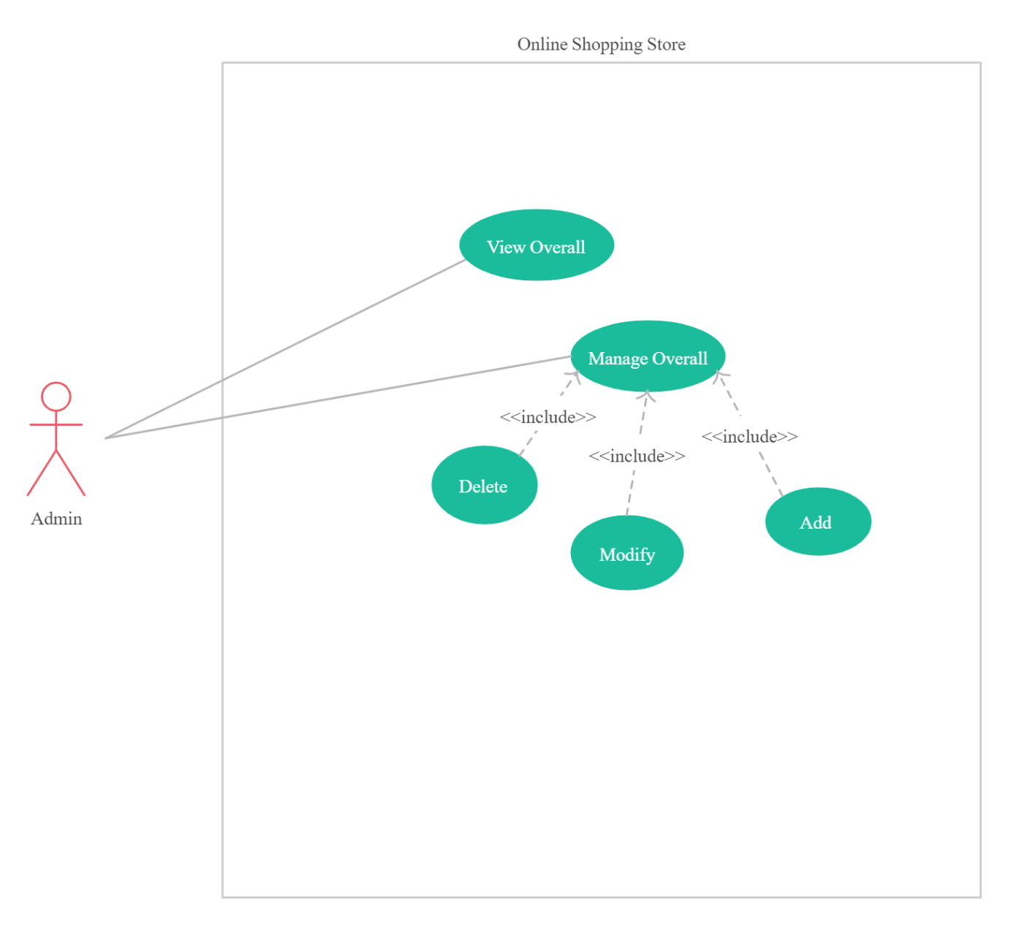

The functionality of an admin is as follows:

* Modify existing customer information if needed
* Modify, add and delete any system user
* Modify, add and delete any role of employee
* Modify, add and delete product details
* Modify, add and delete of product offers and deals

## 3.1.2 Supplier Functionality

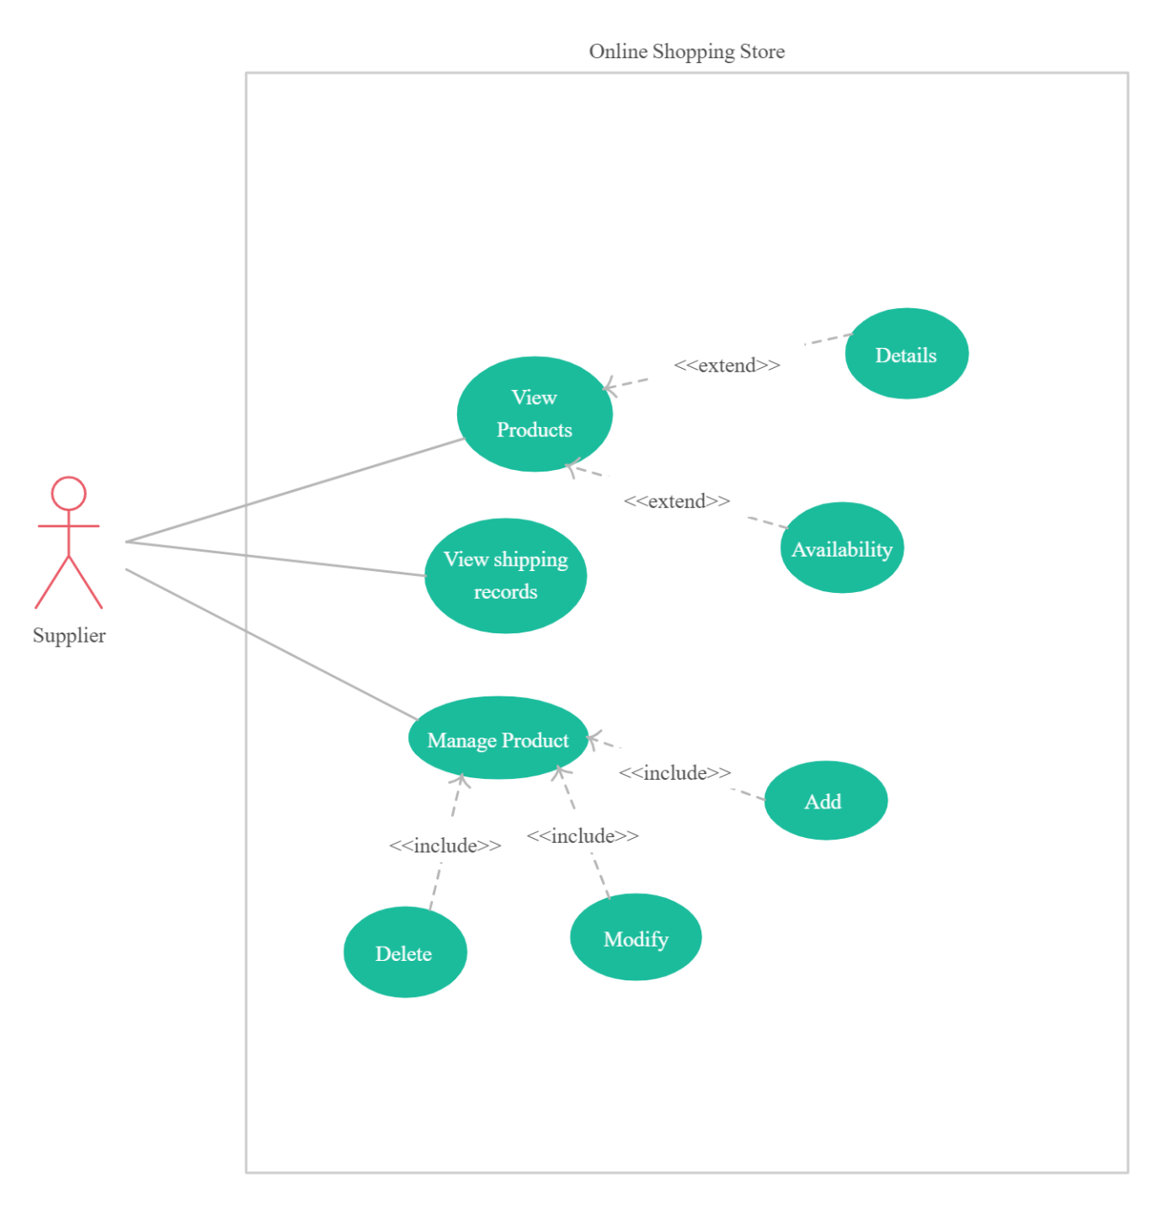

The functionality of a staff is as follows:

* Check supply of products
* View the product shipping records
* Check availability of products
* View the product details
* Modify, add and delete product details if required

## 3.1.3 Unregistered User

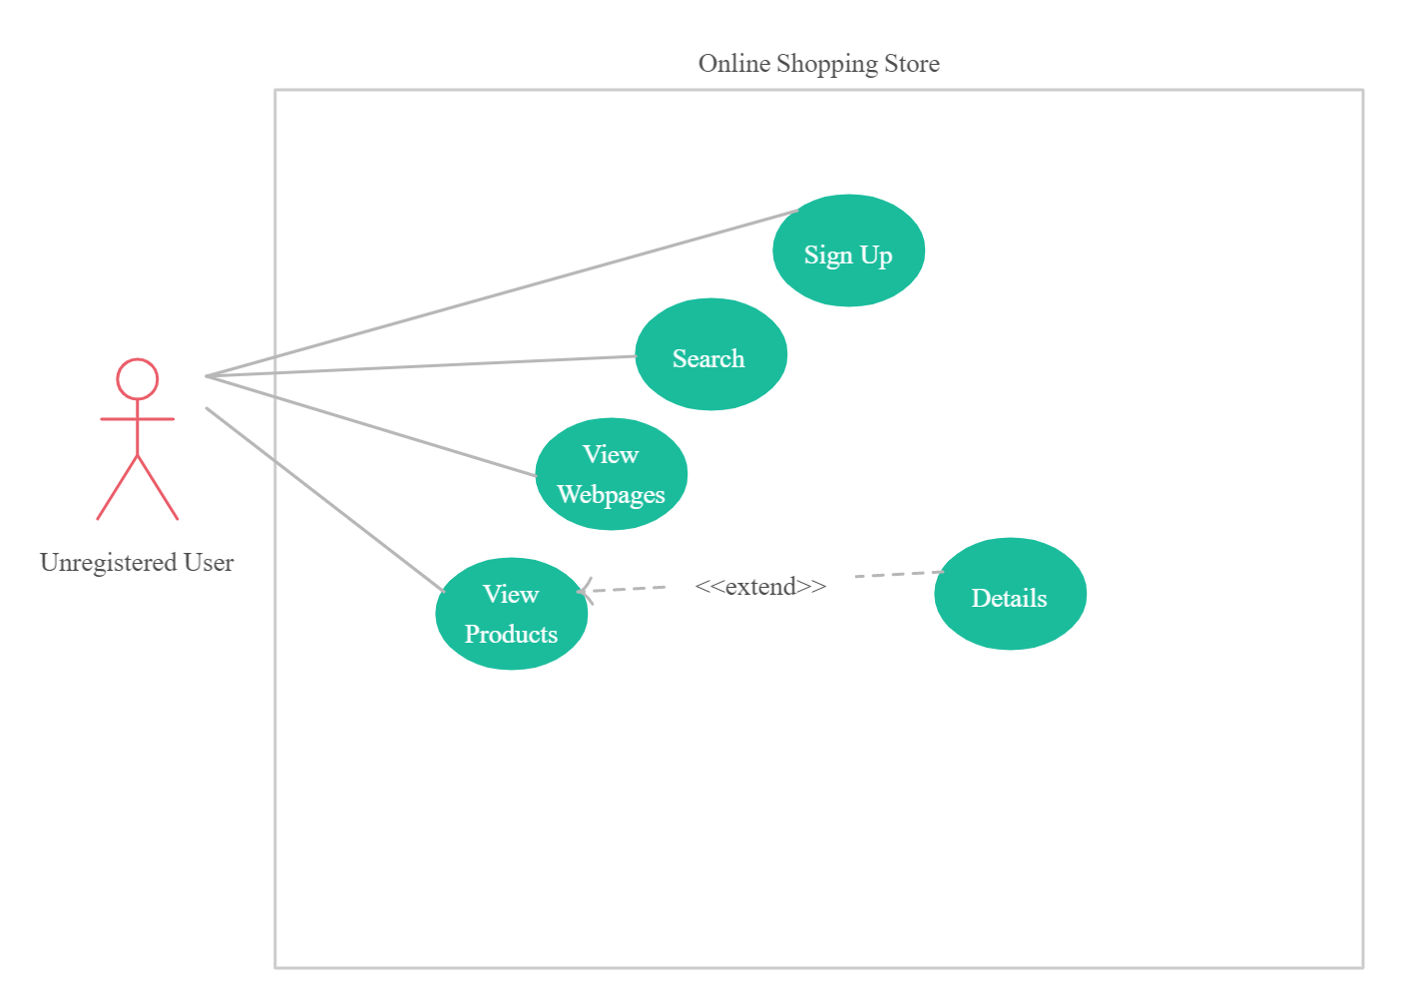

The function of Unregistered user:

* Browse around the website
* View at various products and its details
* Check availability of products
* Use searching filters to find products
* Look at what the website is about
* Create Customer account

## 3.1.4 Registered User

The function of Registered user:

* View the contents of the website
* Look around various products and its details
* Check availability of products
* Apply price comparisons between goods
* Use searching filters to find products
* Look at what the website is about
* Buying products individually
* Buying multiple products using a shopping cart system
* Payment options will be available
* Keep profile of the customer up to date
* View purchasing history
* Give reviews and ratings to products
* Add any product to favorite list

## 3.2 Activity Diagram

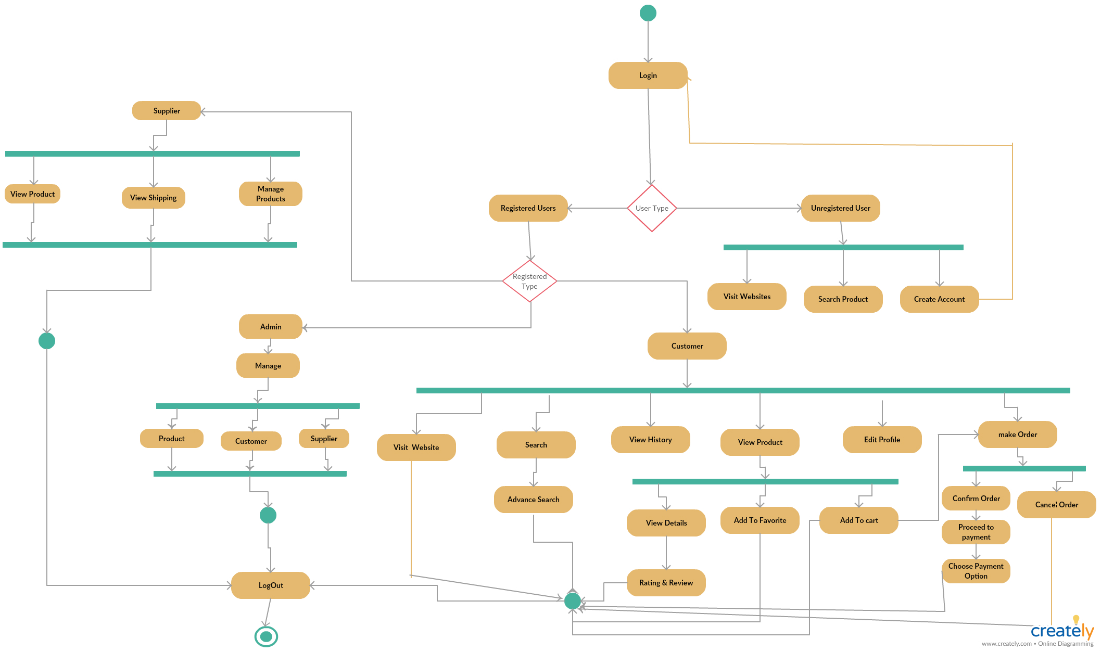

## 3.3 Prototype Images of Proposed System

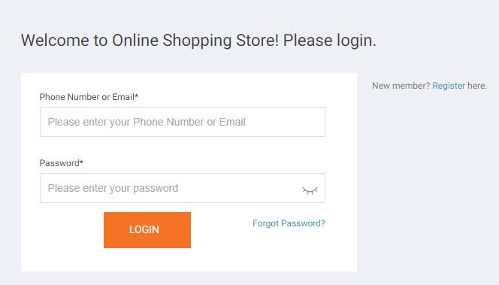

Login

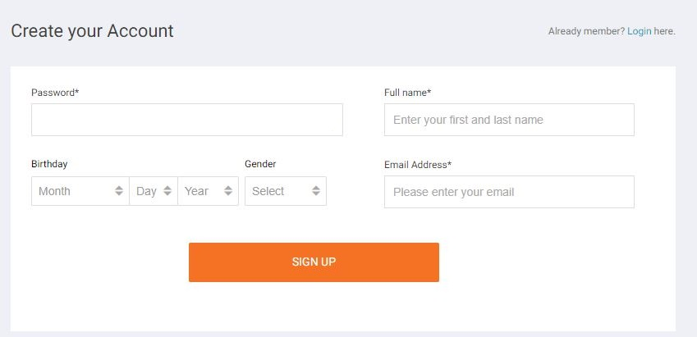

SignUp



Search



Product

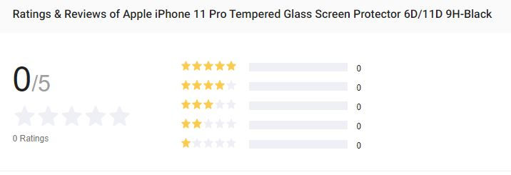

Review

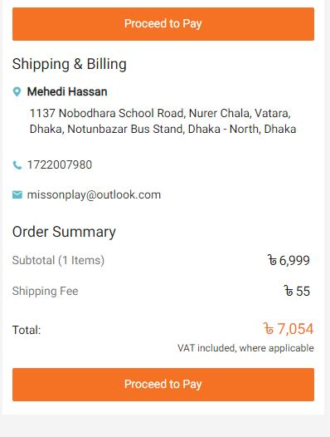

Receipt

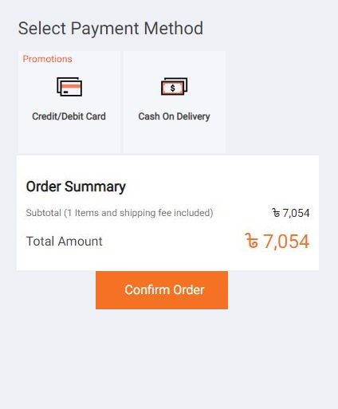

Payment Option & Confirm Order

# Chapter-4: Software Project Management Plan

## 4.1 Document History and Distribution

The System of online shopping stores is used to help the customer to buy the specific product within a short time. There is a category section so that users can easily find the product what they want. Users can buy the product based on an online payment system like credit card, mobile banking or cash on delivery. Users need not go out for buying product and need not waste their time.

## 4.2 Overview

## 4.2.1 Purpose

The main purpose of this project is to find the best quality product in a limited budget within a short time. This system reduces the transportation cost of a user. Also increase the user’s satisfaction and sales of the shop. Functional and non-functional requirements are used to achieve the main goal of the system. In this document all the functional and non functional requirements are described.

## 4.2.2 Project Scope

The online shopping store is supposed to have the following features:

* Easy To Use

Our system help shopper what they want to get.

* Variety of Payment Options

Our system will provide different option for payment method.

* User Review

Give reviews and ratings to the desirable products

* Data scraping or web scraping

Lots of options to compare and contrast for purchasing

* Customer support

Customer support is one of the important e-commerce features. So this system will help customer if he does not know about the functionality properly.

* Opportunities of getting to see various products very easily
* Better searching options based on clients preferences and budgets
* Can buy products individually or in a multiple set via shopping cart
* Customers will be able to buy and find the best offers and deals
* Viewable transaction history provided with details

## 4.2.3 General Constraints

Before implementation we must be focus on the constraints. Time, cost, scope, resources, quality, risk these are the project constrains. Time, cost and scope are the most important constrains because they are dependent on each other.

* Development teams fixed the time schedule.
* Fixed the proper budget estimation.
* Manage the scope of work for the project.
* Need to have proper resources.

If one constrains fail many risk will come like delay on delivery, cross the budget, customer refuse to take the project.

**4.3 Project Deliverables**

**4.3.1 The list of project deliverables is:**

1. Software requirements gathering
2. Draw a Software Design
3. Planning
4. Software development project management.

## 4.3.2 Schedule Summary

|  |  |  |  |
| --- | --- | --- | --- |
| **Serial No.** | **Task** | **Week Number** | **Total Weeks** |
| 1.0 | Feasibility Study | 1st-2nd | 2 |
| 2.1 | Collect Requirement Information | 2nd-3rd | 1 |
| 2.2 | Identify User Requirements | 3rd | 1 |
| 2.3 | Set Requirements | 3rd | 1 |
| 3.0 | Planning | 4th | 1 |
| 4.0 | Designing | 5th-8th | 4 |
| 5.0 | Coding | 8th-11th | 4 |
| 6.1 | Developing Test Plan | 11th | 1 |
| 6.2 | Executing all the Test Phases | 12th | 1 |
| 6.3 | Debugging | 13th-14th | 2 |
| 7.0 | Release | 15th | 1 |
| 8.0 | Documentation | 15th-18nd | 4 |

## 4.4 Resources of the Software Project Management Plan

Planning the evaluation for software is important. Distribute the whole project with the right amount of resources.

|  |  |  |  |
| --- | --- | --- | --- |
| **SL** | **Name** | **Category** | **Quantity** |
| 01 | Project manager | Human Resource | 1 |
| 02 | Analyst | Human Resource | 1 |
| 03 | Designer | Human Resource | 2 |
| 05 | Developer | Human Resource | 4 |
| 07 | Tester | Human Resource | 2 |
| 08 | Laptop | Equipment | 10 |
| 09 | Software | Equipment | As required |
| 10 | Internet Connection | Services | As required |

**4.5 Project Organization**

Project organization describes how to organize a project. It has three important sections.

**4.5.1 External Interfaces**

An ongoing system development it is important that the developers team need to communicate with the customer. They need the specific and clear requirements before building the project. For collecting requirement at first they have to specify the stakeholders. They can collect it from the internal stakeholders or external stakeholders. Many times project fails because of lack of communication. Every conversation will be recorded in the document. Sometimes users demand to update or change the configuration or features then the request comes to the project configuration control board. If the change is approved by CCB then the development team implements the change.

**4.5.2 Internal Structure**

The development team must have the experience of doing work on the multiple modules. In this project there are four members in a team. Every module divided into four members. If one member done his work before the deadline he can work on the others module. The development team can swap their role depending on the situation. This can help the project to meet the objective.

**4.5.3 Roles and Responsibilities**

* The developer teams contribute the whole project objectives.
* They complete their module individually.
* The process is documented by them.
* To meet the business need they communicate with the users.

**4.6 Managerial Process Plans**

**4.6.1 Project Start-up Plan**

The main focus is to set the goal of the project. Set up all the resources and materials what the team member needs. Fixed the deadline and place where they work. All kinds of primary information will be included. All the team members should be attending while preparing startup plan.

**4.6.2 Estimation Plan**

Budget and estimation is the main part of the project. Every project is implemented based on the budget. Project quality depends on this section. Every cost should be included in this part. In this project total development time will be 15 days. And total cost will be BDT. Sometimes it depends on customer demands. Many times clients want to add new features. At this time the cost will become increases.

**4.6.3 Staffing Plan**

At first it is a priority finding the right people for the right job. The development team consists of 4 members. Every member will work for 7 hours in a day. Every project related work will be added in this time. Before starting work every one must see the Gantt chart which will be helpful for delivering the project in due time.

## 4.6.4 Resource Acquisition Plan

Resource describes where we found all kinds of information, data, and manpower everything. Project related all kinds of resources must be available in the working time. The documentation may be changed if the customer wants. And the team member may play a different role based on the project outcome.

## 4.6.5 Project Staff Training Plan

Many times new tools are included to implement the project. At this time developers may be don’t know how to use these types of tools. So they need to train before starting the work. Introduce the new tools and describe how to use.

## 

## 4.7 Budget Allocation Summary

|  |  |  |  |  |  |  |
| --- | --- | --- | --- | --- | --- | --- |
| **Serial No.** | **Employees/Tools** | **Category** | **Number** | **Cost per month** | **Month** | **Total Cost (BDT)** |
| 01 | Project Manager | Staff Cost | 1 | 30,000 | 5 | 150,000 |
| 02 | Analyst | Staff Cost | 1 | 25,000 | 4 | 100,000 |
| 03 | Designers | Staff Cost | 2 | 10,000 | 1 | 20,000 |
| 04 | Developers | Staff Cost | 4 | 20,000 | 1 | 80,000 |
| 05 | Hardware Equipment | Overheads | As required | Not required | Not required | 170,000 |
| 06 | Tools | Overheads | As required | Not required | Not required | 30,000 |
| 07 | Testers | Staff Cost | 2 | 15,000 | 0.5 | 15,000 |
| 08 | Rent | Overheads | As required | 12,000 | 5 | 60,000 |
| 09 | Utilities | Usage Charges | As required | 4,000 | 5 | 20,000 |

The total estimated cost is 645,000 BDT.

## 4.8 Control Plan

## 4.8.1 Requirements Control Plan

At first collect requirements from the stakeholders. Then select all kinds of effective requirements. Requirements are documented in the SRS documents. Development team’s work based on the SRS documents. Requirements are divided into modules. There is a tracking part in the SRS document. So that we can actually understand which module starts am ends. As a result if any change request come via change control box the developer can easily understand actually which module they have to modify or update. It is important for future development.

## 4.8.2 Schedule Control Plan

Scheduling is another important part to deliver the product. There is a Gantt chart in any project. How much time needs to deliver the project. When the first module releases, then the second one does. Everything should be planed. It helps to deliver the final project in due time. The team leader can store some extra time if any bugs come or project related problems come then they can easily handle it and submit it proper time.

**4.8.4 Quality Control Plan**

Measure the quality of the product is essential for any project. Test and defects are the part of quality. Sometimes the development team wants to add testers to find defects. After preparing the project it’s important to test the quality. And ensure that the product is well enough. At first many defects may come. When the testers find the defects, then the development team tries to resolve the defects. In this project the team leader lead the whole control. If any problems come then it is reported to all other members.

**4.8.5 Reporting Plan**

Reporting is mandatory after daily work. This is a day to day responsibility. The team members report the team leader every day. And the team leader reports to the product owner about the progress of the project every week. Everyone can see the status of the project. They can easily know that they are actually achieving the project goal or not in due time. And crossing the limitation of the budget or not. As a result they can observe what to do in this situation.

**4.8.6 Metrics Collection Plan**

Metrics of a project depends on productivity, scope of work, cost, quality and satisfaction.

Utilization of resources, designing, updates features, tracking change requests, quality assurance all of them are included in metrics. Metrics can improve our projects and future updates. Project characteristics are clearly defined here.

## 4.9 Risk Management

All the projects are based on assumption. Risk is the possibility that an assumption is wrong. Risk is the potential problem that might affect the successful completion of a software project. Risk may happen at any time so we have to minimize their impact.

## 4.10 Element of Risk Management



**4.11 Risk Management Plan**

|  |  |  |  |  |
| --- | --- | --- | --- | --- |
| **Risk no** | **Risk Description** | **Probability** | **Impact** | **Mitigation Plan** |
| 1 | Unavailable team member | 20% | Delay project development  (Marginal) | Needs to work individually. Hire more team member if needed. |
| 2 | Not enough time to finish project | 30% | Could no able to deliver the project on time (Critical) | Project team member should finish the work on time. |
| 3 | Inexperienced team member | 20% | Could no able to share the resource properly.(Marginal) | Training inexperienced team member. |
| 4 | Misunderstood requirement | 40% | Inability to deliver product on the due date.(Catastrophic) | Understand every requirement properly. Expense enough time for requirement collection. |
| 5 | Customer change the requirement frequently | 80% | Delay the overall project development.  (Critical) | Documentation of every requirement changes. So that customer will not change it any further. |
| 6 | Delay testing phase due to new issues | 30% | Incomplete testing and late delivery. (Catastrophic) | Testing plan should have to be clear. More time should be taken from the stakeholder. |
| 7 | Staff Turnover | 10% | Directly impact on deliver the project. (Critical) | Increase job satisfaction |

## 4.12 Process Model

We will not concentrate to develop the whole project at once. Rather, we divide the whole project into some mini project. Our first priority is to satisfy the customer as early as possible and also give the freedom to our customer to change requirement at any time. That’s why we need an agile software development method. It’s basically people base rather than plan base.

## 4.13 Methods, Tools and Techniques

The project, E-Commerce, adapts the system on Personal Computer using HTML, PHP, Visual Studio 2012 and MySQL for database management system.

**4.14 Infrastructure Plan**

The hardware resources are 3(three) Intel Dual Core/Core2Duo Personal Computers running Windows XP/Vista/7 or UBUNTU operating system. The project using software resources are like Notepad ++, Adobe Dreamweaver, Adobe Photoshop, Adobe Flash, XAMPP etc.

## 4.15 Product Acceptance Plan

Project manager are responsible for product acceptance plan. At the end of every phase the project manager will perform an acceptance test. The highest priority requirement must be satisfied first. Then remaining major issues and defect have to be solved more quickly.

## 4.16 Monitoring and Control plan

We have to select series of checkpoints in the initial activity plan. It may happen regularly. The team leader needs to monitor the daily progress. We can use activity bar chart which indicates schedule activity dates and duration. Daily report is recorded on that chart and ‘Today Cursor’ provides an immediate visual indication of which activity is ahead and behind schedule. Bar chart provides a visual indication of those activities that are not progressing to schedule.

## 4.17 Verification and Validation

Verification and validation is a process of evaluating software quality. It will include tools, techniques and responsibilities for the verification and validation work activities. The verification and validation plan will be part of a separate document and will be maintained accordingly.

## 4.18 Requirement Tracing Plan

Requirement tracing is really important to find any missing or unnecessary requirement. If we do not trace requirement there is a possibility that our system will be affected if we add, delete or modify a particular requirement. We can use different kind of traceability matrix



This is one kind of requirement traceable matrix. This table show how each functional requirement is linked backward to a specific use case and forward to one or more design, code and testing element.

## 4.19 Documentation Plan

The primary objective for documentation is to guarantee that developer and customer are going a similar way to achieve the goals of the task. To accomplish them, a lot of documentation types exist. All the documents would be discussed and reviewed with project manager.

## 4.20 Quality Assurance Plan

It is insufficient to ensure that the project will be developed on time. Customer satisfaction is the main priority for building any kinds of project. That’s why the quality of our project will be maintained and checked by the project manager. He will assure that this project is maintaining the quality.

## 4.21 Problem Resolution Plan

The project management plan will specify the plans, methods and techniques for reporting and resolution of problems created during project. The SPMP will be updated accordingly should the need for such a plan arises.

## 4.22 Process Improvement Plan

In process improvement, project manager needs to find a way of the most proficient method to improve the current plan. Project manager will be evaluating all the current plans and suggest an idea if there is any missing or unnecessary requirement.

## 4.23 Conclusion

This document has been developed based on the study materials and references we found that is related to the project. This is referred to as Requirement Specification Document. Common and previous scenarios and projects helped our whole team to make this document possible. Thus, when the team starts development, they can look at this document and try to solve any unusual circumstances that may rise on the process of development.

## REFERENCES

1. https://www.userlike.com/en/amp/blog/auto-reply-message-sample-for-business
2. https://www.rightinbox.com/blog/automated-email-responses-examples
3. https://blog.servicedock.com/blog/auto-responses-customer-service
4. https://acquire.io/blog/problems-solutions-ecommerce-faces/
5. https://www.whoishostingthis.com/blog/2017/07/27/ecommerce-problems/
6. https://optinmonster.com/ecommerce-business-challenges-solutions/
7. http://www.shopio.com/blog/7-most-common-ecommerce-problems-and-solutions-for-customer-satisfaction/
8. https://ecommercetrainingacademy.com/ecommerce-business-challeges/
9. https://www.researchgate.net/publication/322991992_Importance_of_UML_Diagrams_in_Software_Development
10. https://tallyfy.com/uml-diagram
11. https://www.bluescape.com/everything-you-need-to-know-about-uml-diagram
12. https://www.visual-paradigm.com/tutorials/how-to-draw-activity-diagram-in-uml/
13. http://agilemodeling.com/style/activityDiagram.htm
14. https://www.guru99.com/uml-class-diagram.html
15. Shopping Cart Software: eCommernce Solutions & Hosting, www.oscommerce.com/
16. www.theirm.org/publications/documents/Risk_Management_Standard_030820.pdf
17. http://www.agilemodeling.com/style/useCaseDiagram.htm
18. https://projectbliss.net/project-assumptions-list/
19. https://pmi-nnv.org/document-repository/presentation-archive/621-pmi-nnv-may-2014-project-assumptions-constraints/file
20. https://www.archimetric.com/10_tips_to_create_professional_use_case_diagram/
21. https://www.phe.gov/about/amcg/contracts/Documents/risk-management.pdf
22. https://www.xeonbd.com/domain
23. https://en.wikipedia.org/wiki/Risk_management_plan
24. http://en.wikipedia.org/wiki/Software_project_management
25. https://www.webhostbd.com/domain-price
26. https://www.tutorialspoint.com/uml/uml_use_case_diagram.htm
27. https://resources.sei.cmu.edu/asset_files/TechnicalNote/2004_004_001_14327.pdf
28. http://alexandre-plennevaux.infographie-heaj.eu/e-book%20collection/The%20Principles%20Of%20Project%20Management.pdf
29. https://bookboon.com/en/project-management-ebooks
30. https://epdf.tips/project-management.html
31. https://www.cio.com/article/2914780/12-ways-to-improve-the-customer-experience-for-online-shoppers.html
32. https://www.shopify.com/blog/customer-service